E (13th) D69/E A(add9)/E E(13th) D69/E A(add9)/E
For satan is under our feet, and his kingdom has suffered defeat.
E (13th) D69/E A(add9)/E
By the blood of the lamb and his word,
E (13th) D69/E A(add9)/E
So rejoice saints throughout all the earth.
Chorus
E D A E D A E
Victory! We cry aloud and decree, the hosts of all heaven will see.
D A E D A E
The kingdom of God come in glory, shout it aloud, victory!
E (13th) D69/E A(add9)/E
For the kings of the earth will bow down,
E (13th) D69/E A(add9)/E
And the elders will cast down their crowns.
E (13th) D69/E A(add9)/E
And the nations will reverence your name,
E (13th) D69/E A(add9)/E
And your people will sing and proclaim.
E (13th) D69/E A(add9)/E
Then the righteous will be seated on thrones,
E (13th) D69/E A(add9)/E
And your justice will clearly be shown.
E (13th) D69/E A(add9)/E E (13th) D69/E A(add9)/E
To a world that has bended the knee, For the war has been won and we’re free.
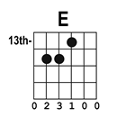 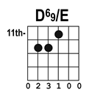 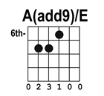By Benjamin Anderson ©2013

